Curriculum Overview – Long Term Planning (2025-2026)

MATHS OVERVIEW
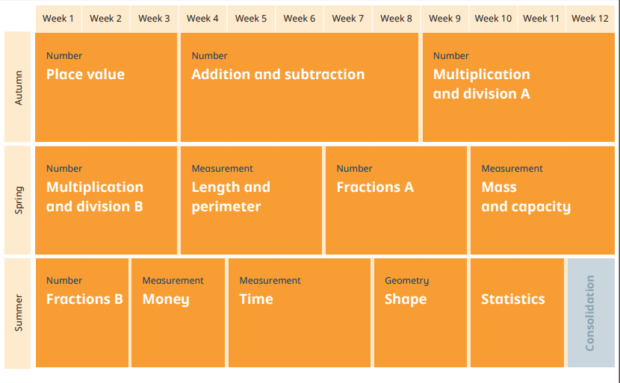

 | AUTUMN  Term 1 & Term 2 | SPRING  Term 3 & Term 4 | SUMMER  Term 5 & Term 6
MATHS OBJECTIVES | Number – Place Value  Count from 0 in multiples of 4, 8, 50 and 100; find 10 or 100 more or less than a given number.  Recognise the place value of each digit in a 3-digit number (100s, 10s, 1s).  Compare and order numbers up to 1,000.  Identify, represent and estimate numbers using different representations.  Read and write numbers up to 1,000 in numerals and in words.  Solve number problems and practical problems involving these ideas.  Number – Addition & Subtraction  Add and subtract numbers mentally, including: a three-digit number and ones; a three-digit number and tens; a three digit number and hundreds.  Add and subtract numbers with up to three digits, using formal written methods of columnar addition and subtraction.  Estimate the answer to a calculation and use inverse operations to check answers.  Solve problems, including missing number problems, using number facts, place value, and more complex addition and subtraction.  Number – Multiplication & Division  Recall and use multiplication and division facts for the 3, 4 and 8 multiplication tables.  Write and calculate mathematical statements for multiplication and division using the multiplication tables they know, including for two-digit numbers times one-digit numbers, using mental and progressing to formal written methods.  Solve problems, including missing number problems, involving multiplication and division, including positive integer scaling problems and correspondence problems in which n objects are connected to m objects. | Number – Multiplication & Division (finish objectives from Term 2)  Measurement – Length and Perimeter  Measure, compare, add and subtract lengths (m/cm/mm).  Measure the perimeter of simple 2D shapes.  Number – Fractions  Count up and down in tenths; recognise that tenths arise from dividing an object into 10 equal parts and in dividing one-digit numbers or quantities by 10.  Recognise, find and write fractions of a discrete set of objects: unit fractions and non-unit fractions with small denominators.  Recognise and use fractions as numbers: unit fractions and non-unit fractions with small denominators.  Recognise and show, using diagrams, equivalent fractions with small denominators.  Add and subtract fractions with the same denominator within one whole (for example,$\frac{5}{7 }+\frac{1}{7}=\frac{6}{7}$ ).  Compare and order unit fractions, and fractions with the same denominators.  Solve problems that involve all of the above.  Measurement – Mass and Capacity  Measure, compare, add and subtract mass (kg/g) and volume/capacity (l/ml). | Number – Fractions  (finish objectives from Term 4)  Measurement – Money  Add and subtract amounts of money to give change, using both £ and p in practical contexts.  Measurement – Time  Tell and write the time from an analogue clock, including using Roman numerals from I to XII, and 12-hour and 24-hour clocks.  Estimate and read time with increasing accuracy to the nearest minute.  Record and compare time in terms of seconds, minutes and hours.  Use vocabulary such as o’clock, am/pm, morning, afternoon, noon and midnight.  Know the number of seconds in a minute and the number of days in each month, year and leap year.  Compare durations of events (for example to calculate the time taken by particular events or tasks).  Geometry – Properties of Shapes  Recognise angles as a property of shape or a description of a turn.  Identify right angles, recognise that two right angles make a half-turn, three make three quarters of a turn and four a complete turn; identify whether angles are greater than or less than a right angle.  Identify horizontal and vertical lines and pairs of perpendicular and parallel lines.  Draw 2D shapes and make 3D shapes using modelling materials.  Recognise 3D shapes in different orientations and describe them.  Statistics  Interpret and present data using bar charts, pictograms and tables.  Solve one-step and two-step questions (for example, ‘How many more?’ and ‘How many fewer?’) using information presented in scaled bar charts and pictograms and tables.
ENGLISH | Term 1:  Unit 1- Story Writing: Eliot Jones Midnight Superhero (Anne Cottringer)  Unit 2- Diary Entries: Matilda (Roald Dahl)  Unit 3- Instructional Texts: Stone Giant and Water Goblin (Pie Corbett)  Term 2:  Unit 4- Whole-school text: TBC  Unit 5- Adventure Stories: Adventure at Sandy Cove (Pie Corbett) | Term 3:  Unit 6- Story Writing: Escape from Pompeii (Christina Balit)  Unit 7- Poetry: Magic Box  Term 4:  Unit 8- Whole-school text: TBC  Unit 9- Comprehension and Grammar skills | Term 5:  Unit 9- Story Writing: Jack and the Beanstalk  Unit 11- Non-Chronological Reports: Linked to Rivers topic  Term 6:  Unit 12- Descriptive story writing: Rhythm of the Rain (Grahame Baker-Smith)  Unit 13- River poetry

READING  Daily whole-class and independent reading.  Vocabulary will be pre-taught for class texts. | Term 1:  - Matilda  - Class Novels chosen by teacher  - Guided Reading  Term 2:  - Whole-school text  - Class Novels chosen by teacher  - Guided Reading | Term 3:  - Escape from Pompeii  - Class Novels chosen by teacher  - Guided Reading  Term 4:  - Whole-school text  - Class Novels chosen by teacher  - Guided Reading | Term 5:  - Jack and the Beanstalk  - Class Novels chosen by teacher  - Guided Reading  Term 6:  - Rhythm of the Rain  - Class Novels chosen by teacher  - Guided Reading
COMPREHENSION | Terms 1 & 2:  - Understanding words  - Finding information  - Identifying the main idea  - Sequencing | Terms 3 & 4:  - Finding similarities and differences  - Predicting  - Concluding  - Summarising | Terms 5 & 6:  - Inferring  - Cause and effect  - Fact or opinion  - Point of view and purpose
GRAMMAR AND  PUNCTUATION | Term 1:  - Alphabet and using a dictionary  - Capital letters and full stops  - Statements, commands, questions, exclamations  - Nouns, verbs and adjectives  - Conjunctions  - Fronted adverbials  - A and an  - Commas in a list  - Singular and plural nouns  Term 2:  - Adverbs  - Revision: nouns, verbs and adjectives  - Phrase and clause  - Expanded noun phrases  - Apostrophes for contraction  - Inverted commas for direct speech | Term 3:  - Prepositions  - Revision: nouns, verbs, adjectives, adverbs  - Subordinate clauses  - Apostrophes for singular possession  - Revision: inverted commas for speech  Term 4:  - Revision: nouns, verbs, adjectives, adverbs, prepositions  - Simple past and present tenses  - Progressive past and present tenses | Term 5:  - Conjunctions  - Revision: nouns, verbs, adjectives, adverbs and prepositions  - Revision: inverted commas for speech  - Headings and sub-headings  - Present perfect tense  Term 6:  - Revision: nouns, verbs, adjectives, adverbs and prepositions  - Common and proper nouns  - Subordinating and coordinating conjunctions  - Paragraphs  - Revision: expanded noun phrases

SPELLING  One weekly spelling lesson teaching spelling rules, to ensure full coverage of the National Curriculum. | Terms 1 & 2:  Weekly spelling lessons to include:  - Suffixes  - Prefixes  - Apostrophes for contraction  - Rarer GPCs  - Homophones  - Prefixes ‘mis’ and ‘re’  - The /ɪ/ sound spelt ‘y’ | Terms 3 & 4:  Weekly spelling lessons to include:  - Words ending with the /g/ sound spelt ‘-gue’ and the /k/ sound spelt ‘-que’  - Revision of ‘ness’ and ‘ful’ suffixes following a consonant  - Prefixes ‘sub’ and ‘tele’  - Words with the /ʃ/ sound spelt ‘ch’ as well as ‘s’, ‘ss(ion/ure’)  - Suffixes ‘ness’, ‘less’, ‘ful’ and ‘ly’  - Revision of suffixes (‘ed’, ‘ing’, ‘s’, ‘es’, ‘ed’, ‘ing’, ‘s’ and ‘es’) | Terms 5 & 6:  Weekly spelling lessons to include:  - Prefixes ‘super’ and ‘auto’  - Words with the /k/ sound spelt ‘ch’  - Suffix ‘ly’ with root words ending in ‘le’ and ‘ic’  - Revision of vowel digraphs  - The /ʌ/ sound spelt ‘ou’  - Revision of any other rules
HANDWRITING PROGRESSION | - Pencil grip and posture  - Straight Line Family: i, l, t, x, z.  - Curves to Start Family: c, a, d, g, q, o, e, s.  - Top Exit Family: r, v, w.  - Tunnels Family: n, m, h, b, p, u.  - Hooks, Loops and Lines Family: j, y, f, k.
SCIENCE | Term 1: Rocks and fossils  Term 2: Animals, including humans | Terms 3: Forces and Magnets  Term 4: Light | Term 5: Living things  Term 6: Scientific enquiry
COMPUTING | Term 1: Connecting computers  Term 2: Basic computer skills | Term 3: Programming A: Sequencing sounds  Term 4: Online safety: Project evolve | Term 5: Animation: Zu3D  Term 6: Programming B: Events & actions in programs
HISTORY |  | Roman Britain
GEOGRAPHY | Local Area |  | Rivers
PE | Term 1: Yoga  Term 2: Dance | Term 3: Fitness  Term 4: Gymnastics | Term 5: Tennis  Term 6: Outdoor Athletics
GAMES | Term 1: Handball  Term 2: Tag Rugby, Football & Netball | Term 3: Tag Rugby, Football & Netball  Term 4: Tag Rugby, Football & Netball | Term 5: Cricket & Rounders  Term 6: Cricket & Rounders
ART & D.T. | Term 1: Hundertwasser  Term 2: Art linked to whole-school book  Christmas pop-ups | Term 3 : Roman Mosaics  Term 4: Art linked to whole-school book  Roman Catapults | Term 5: Monet – Water lilies (watercolour)  Term 6: Healthy pizzas

R.E. | Term 1: What do different people believe about God?  Term 2: What does it mean to be a Christian living in Britain today? | Term 3 & 4: Festivals | Term 5: Praying  Terms 6: The Bible
FRENCH | Term 1+2: Phonics/ I am learning French | Term 3+4: Animals | Term 5+6: Instruments
MUSIC | Term 1: Creating compositions in response to an animation (Theme: Mountains)  Term 2: Developing singing technique (Theme: the Vikings) | Term 3: Ballads  Term 4: Pentatonic melodies and composition (Theme: Chinese New Year) | Term 5: Jazz  Term 6: Traditional instruments and improvisation (Theme: India)
PSHE | Term 1: Trust  We will act responsibly and honestly to earn the trust of each other at Amherst School.  - Classroom rules  - School council  - Water safety  - Active citizens  - Zones of Regulation  Term 2: Kindness  We will treat everybody and everything with care and respect at Amherst School.  - Family units  - Anti-bullying  - Self-kindness  - Bereavement  - Family changes | Term 3: Determination  We will work hard to do our best even when things are difficult.  - Growth mindset  - Resilience and inspirational people  - Mental health awareness  - Financial awareness  Term 4: Politeness  We will be well-mannered and courteous towards everyone at Amherst School.  - Speaking and listening  - Manners  - Table manners  - Compliments  - The environment  - Personal hygiene | Term 5 – Fairness  We will treat everyone as our equal(s) at Amherst School.  - Rights and responsibilities  - Diversity  - Mental wellbeing  - Bullying  Term 6 – Co-operation  We will all work together to include each other as a team at Amherst School.  - Communities  - Transition  - Cooperation  - Diversity  - Change
PROVISIONAL  TRIPS / VISITORS | Autumn 1: Rocks Day at Amherst  Autumn 2: Pantomime | Spring 1: Science Show  Spring 2: Roman Day at Amherst | Summer 1  Summer 2: Rivers trip

